1. 00:d0:59:a9:3d:68
2. 00:06:25:da:af:73
   1. No
   2. It is the mac address of the router
3. IPv4 (0x0800)
   1. IP
4. 52 bytes
5. 00:06:25:da:af:73
   1. No
   2. It is the mac address of the router
6. 00:d0:59:a9:3d:68
   1. Yes
7. IPv4 (0x0800)
   1. IP
8. 13 bytes

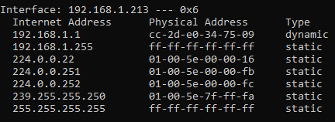

* 1. Internet Address: IP
  2. Physical Address: MAC address
  3. Type: protocol type
  4. Source: 4c:cc:6a:d5:11:71
  5. Destination: ff:ff:ff:ff:ff:ff

1. ARP: (0x0806)
2. 1. 20 bytes
   2. Opcode: reply (1)
   3. Yes, Sender: 192.168.1.105
   4. Target MAC: 00:00:00:00:00:00
   5. 20 bytes
   6. Opcode: reply (2)
   7. Sender MAC address: 00:06:25:da:af:73
3. 1. Destination: 00:d0:59:a9:3d:68
   2. Source: 00:06:25:da:af:73
4. This is not the computer that sent the request.

Extra:

1. If the IP was correct, the physical address would be corrected.

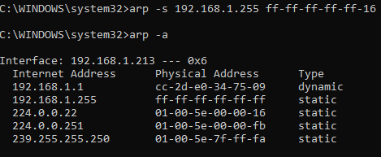

1. Default is 21600 seconds.